Preprocessing data:
File locations:
1: (ccstorage2)Z:\Alie\Scripts
2: BORON F:\Alie\Scripts

Note: would recommend using the script location on the same computer and drive as where your data is located. Files are very large so copying them into a different location is painful. **preprocessing can be done without BORON. You can just copy your final binary file

FUNCTION: KilosortFormat
- Kilosort requires data in one binary file int 16 type matrix that is organized channels x time. Use this function to process your Full LFP files
- Inputs: probelayout, mouse, shanks, time, dir
  - Probe layout: matrix of channel numbers x shanks (make sure it’s just a single double with the channel numbers organized chans x shank)
  - Mouse: mouse name
  - Shanks: which shanks to process
  - Time: (seconds) how much of file to process
  - dir : desired binary file output *make sure there’s a final \ at end of dir
- Outputs: ShankX, binaryShankX
  - Outputs 2 files for each shank input - one regular matrix and one binary file for kilosort input
    - both files chans x time
  - This file is sorted in order of the actual probe layout. Ie channel 1 = first channel on top of probe not channel called channel 1
TO RUN: set working directory to location of your full files then call KilosortFormat and it will automatically run in the correct location. Have correct probelayout loaded in your local environment.

Function: ExampleChanMap
- Need channel map file to input into kilosort. Kilosort will save every channel map file you make after you load it into the gui so this should only be done once/shanktype for every computer that runs kilosort
  - This is done for 256A probes. See file ‘256 Probe XY Coords’ in Kilosort folder.
- Adapted from kilosort function ‘createChannelMapFile’
- What to change for your probe:
- Number of channels
- X coords: X coordinate in microns. Middle = 0, right shift = num microns, left shift = -num microns
- Y coords: depth in microns

Note: susie installed kilosort 3 on Boron 9/14, now the default boot up kilosort on boron is 3

Running Kilosort:
File location: BORON: C:\ProgramFiles\MATLAB\2017a\Kilosort2-master
**currently only working on BORON

Github link: https://github.com/MouseLand/Kilosort
Alternate Github link: https://github.com/cortex-lab/KiloSort/blob/master/readme.md
Version 2.0 used by shuman lab summer 2021 (there is up to kilosort 3.0 but is not currently compatible with needed features of phy and does not function with gui)
%Susie uses 2.5 on boron, Zoe uses 2.5 on her computer
Npy-Matlab download link:
https://github.com/kwikteam/npy-matlab

Installation:
- Download code from github (link above) and save into current MATLAB folder
- Make sure you have a CUDA compatible compiler installed on your computer - see troubleshooting below for details
- Run ‘kilosort’ in command window in MATLAB. The first time you do this will take longer.
- Must have npy-matlab repository downloaded into MATLAB folder and added to path. Some output files of kilosort/phy are saved as python files and npy is required to read those. Specifically the function readNPY is used in PhyOutput function. Link is above

Using the GUI:
- When kilosort is working and installed, type ‘kilosort’ into command prompt in MATLAB and gui should appear
- Inputs:
  - Channel map file (saves after loading the 1st time)
  - binary int16 matrix from KilosortFormat function **Only do one shank at a time!
  - Sampling frequency - 25k
- Set working directory and output directory to desired output location. Kilosort outputs a lot of files so I would recommend having this be an empty folder for each mouse and one of its shanks.
- Note: “Warning: Data must be raw binary. Other file types not supported” comes up whenever you load data. Don’t be alarmed. It should still run.
- Hit ‘Run All’

Output:
Documentation for outputs:
https://github.com/MouseLand/Kilosort/wiki/7.-Output-variables
https://github.com/kwikteam/phy-contrib/blob/master/docs/template-gui.md

- Phy will update the output. The commands for Phy will automatically load all of the kilosort output into the gui for Phy. There’s no need to touch kilosort’s output immediately

Manual Clustering with Phy:
File location: BORON C:\Users\Chris\anaconda3
Github link: https://github.com/cortex-lab/phy
Version 2.0 used by shuman lab summer 2021 (current version)

Note: Phy is a program that is made to load the output of kilosort and allow manual updating of output. Kilosort frequently labels noise as biological clusters so this step is necessary.
Close matlab and other programs as much as possible before running phy to ensure it runs smoothly/doesn’t lag.

Launching phy
- Launch anaconda terminal window
- Make sure phy is installed in anaconda folder
  - Notation for first install:
conda create -n phy2 python=3.7 pip numpy matplotlib scipy scikit-learn h5py pyqt cython pillow -y

conda create -n phy2 python=3.7 pip numpy matplotlib scipy scikit-learn h5py pyqt=5.9.2 qt=5.9.7 cython pillow -y

conda activate phy2

pip install phy --pre --upgrade
- Set current directory for location of kilosort output
  - Note: to change disk location (ex local disk C to F) notation is just whateverterminalsays> f:
  - To change directory within that disk use >cd Alie\My\File\Location
- ‘conda activate phy2’
  - This allows you to call phy functions
Run >
phy template-gui params.py
Or: phy template-gui params.py --clear-cache --clear-state (to make it faster)
  - This should launch phy gui
  - Make sure your current directory contains your kilosort output files

Manual clustering
Sorting guide: https://phy.readthedocs.io/en/latest/sorting_user_guide/
https://github.com/kwikteam/phy-contrib/blob/master/docs/template-gui.mdT
- End goal of phy is to label each cluster ‘good’, ‘mua’, or ‘noise’
  - When cluster is selected in ‘ClusterView’ use Alt+ g = good, Alt + m = MUA, Alt+ n = noise to label.
  - Merge similar cluster: select similar cluster then ‘G”
  - manual cut on feature view: hold control, then left click to circle out refined cluster, after circling, press K. If want to redo, hold control + right click
- If phy crashes, just close the window and the terminal and reload. You may need to reload a couple times. The first time you load a file it make take a couple tries to get phy working.
- Most useful views: Amplitude view, waveform view, feature view.
  - https://github.com/kwikteam/phy-contrib/blob/master/docs/template-gui.md
  - See these snippets from the official guide for info about these views:

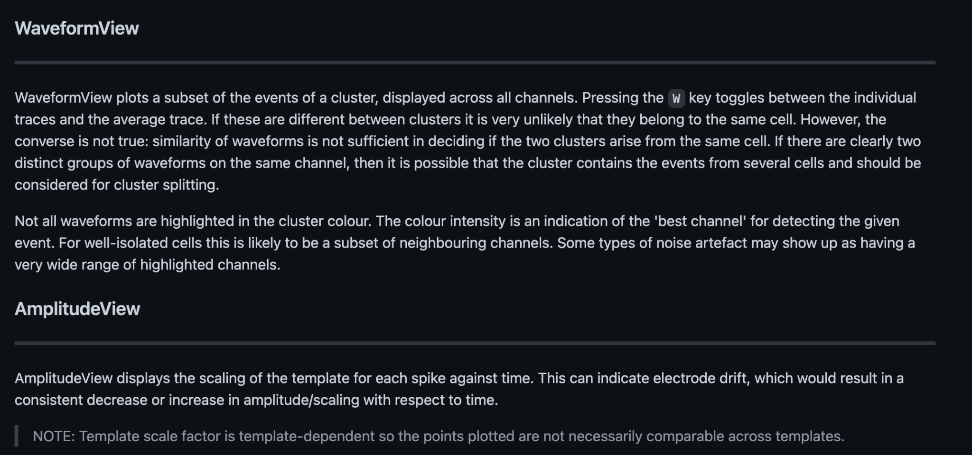

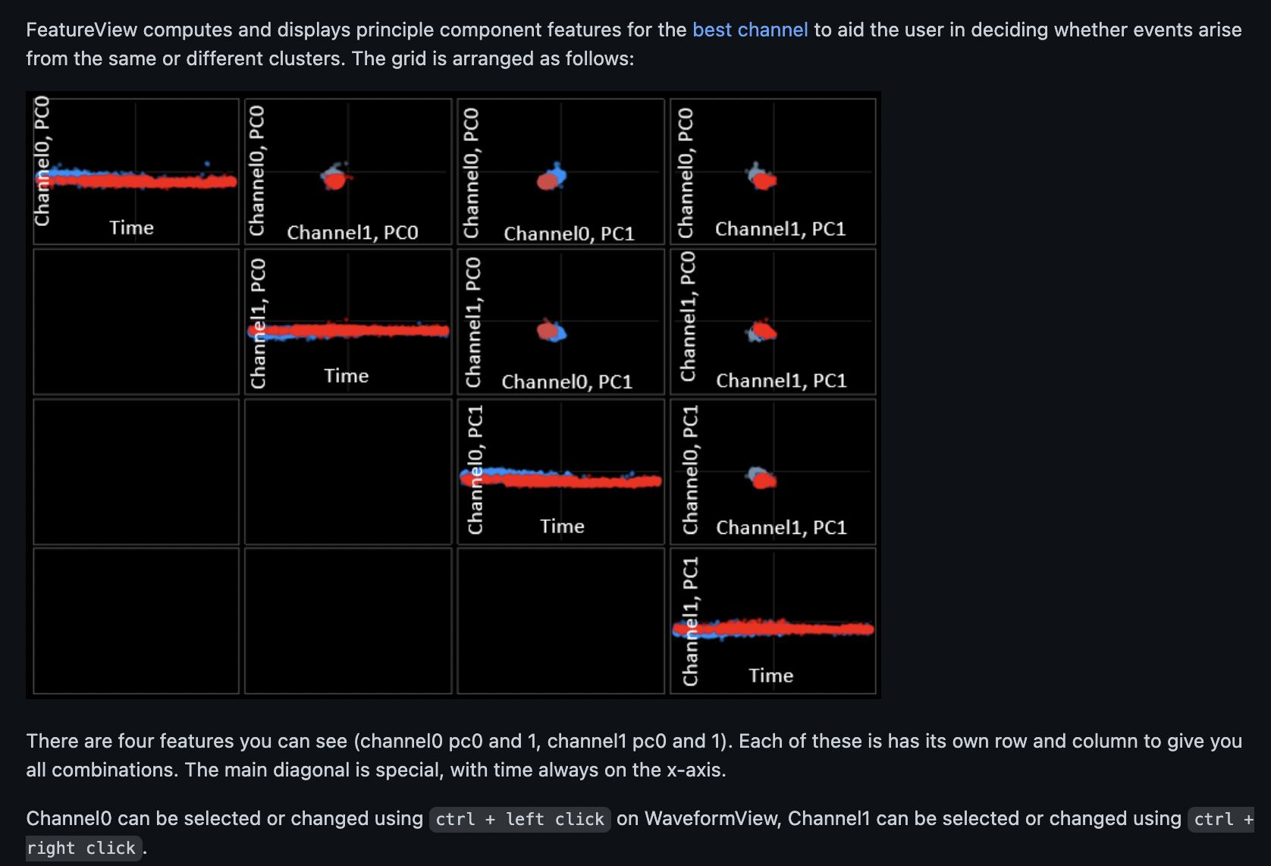
General Comments from Alie:
- ContamPct is a measure of the refractory period violations- if it is above 20% it automatically rounds to 100%. This is mainly how Kilosort labels clusters MUA over good. Some of these cells look good to me and I would consider labeling some of them as good as you see fit (maybe after removing some waveforms). For now I didn’t.
- Loading phy- sometimes takes 2 tries when first opening phy for one file output. Just keep trying.

Final data output:
Understanding Phy output: https://github.com/kwikteam/phy-contrib/blob/master/docs/template-gui.md
https://github.com/cortex-lab/spikes/find/master

FUNCTION: PhyOutput
- Phy updates the files that kilosort outputs. This interprets these files and makes a units structure
- Inputs: dir
  - dir : location of kilosort output for one mouse one shank
- Output: cells.mat
  - Cells contains two structures units and MUA
    - Units: ‘good’ clusters only, each row in structure corresponds to one cluster
    - MUA: ‘mua’ clusters only, each row in structure corresponds to one cluster
  - Contained in Units and MUA
    - spiketimes: sample number of each spike event for cluster
    - Num_spikes: total number of spike samples in each cluster
    - cluster_id: cluster number (+1 from what is shown in phy because python indexes from 0)
    - highest_chan: channel that contributes most waveforms to cluster (+1 from what is shown in phy because python indexes from 0)
    - amplitudes: spike amplitude for each sample in cluster
TO RUN: set dir to kilosort/phy output directory and run PhyOutput(dir)

SF: In order to get readNPY function work in matlab on your own PC, follow this: https://github.com/kwikteam/npy-matlab

Various Troubleshooting:

Kilosort installation problems FOR MATLAB 2017A:
- Compiler not installed
- When running kilosort for the first time you will get a mex error if your computer does not have a CUDA compatible compiler
- Recommend downloading community Visual Studio 2013!!!!!!! (download before CUDA)
  - the files to download
  - https://visualstudio.microsoft.com/vs/older-downloads/
  - in order to download, you need to
- Make sure CUDA version is compatible with compiler and MATLAB 2017a
  - CUDA version 8.0 <ga2> https://developer.nvidia.com/cuda-80-ga2-download-archive
- Helpful matlab commands
  - mex -setup to check if compiler is installed
  - gpuDevice to see gpu/ compiler information

When you type into command prompt: “nvcc --version”
It should give you this information:
nvcc: NVIDIA (R) Cuda compiler driver
Copyright (c) 2005-2016 NVIDIA Corporation
Built on Mon_Jan__9_17:32:33_CST_2017
Cuda compilation tools, release 8.0, V8.0.60

If you’re working with a different version of Matlab, check this table to see which version of CUDA you need: https://www.mathworks.com/help/parallel-computing/gpu-support-by-release.html
And then check which version of Visual Studio you need.

Phy gui performance being slow/bad:

- Make sure your GPU driver is updated and your kilosort and phy outputs are using your high performance GPU
- Dowloading updated NVIDIA driver: https://developer.nvidia.com/cuda-downloads?target_os=Windows&target_arch=x86_64&target_version=10&target_type=exe_local
- Updating GPU output: Windows settings > Display > Graphics Settings
  - Browse in anaconda3 folder and phy subfolder. Set all _conda.exe and python.exe to High performance GPU output.
- Phy crashes a lot. Reload it. Close the anaconda terminal and reactivate and reload fully.

For error “ImportError: DLL load failed while importing _imaging”
conda uninstall Pillow
pip install Pillow

